Chin Tucks
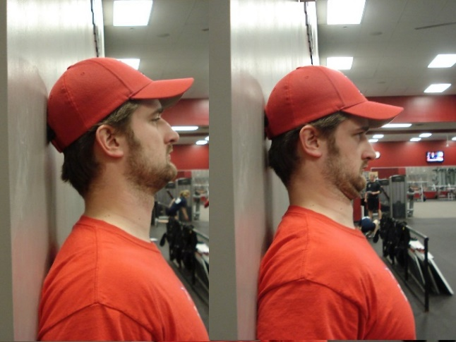 | Hold: 5 - 10sec  Reps: 10 x session  Sets: 1 - 3 x day  *Can be done at the traffic Lights, at your desk or even on the toilet.
Wall Slides/Scap. Retraction
Sitting on a stool or in a wall sit position with back against wall, arms raised overhead.
Keeping forearms and back of hands in contact with the wall at all times, slowly slide arms up and down wall as you squeeze shoulder blades together.

Hold: 4-10sec
Reps: 15-20
Sets: 2-3
Rest: 30-60sec
1 - 3 x day

Neck posture exercises.doc

